Experiment R: Reaction Thermodynamics

Observation Sheet: Reaction Thermodynamics
* Be sure to use the concentration of the stock solution you prepared as per Step 4 on page R-8
Volume of SCN–(aq) 10.00___ mL [SCN–] stock solution* _0.00206__ mol/L
Volume of Fe³⁺(aq) _10.00__ mL [Fe³⁺] stock solution __0.00208______ mol/L
[Fe³⁺]_{i}
Iron filling in the reaction. The ions react in excess.
(-204.30+3×(0))
Less (10 +3×(-73.29)
=4.681kcal
[SCN–]_{i}
SCN aq reaction in ratio 1:2
at same volume 10ml
Implies.
4.681÷2=2.345 kcal
Show Calculations for [Fe³⁺]_{i} and [SCN–]_{i} (i.e. after mixing but before reaction commences):

Time (s) | Temp (°C) | Absorbance |  | Time (s) | Temp (°C) | Absorbance
30 | 68.2 | 0.399 |  | 480 | 46.3 | 0.429
60 | 65.2 | 0.403 |  | 510 | 45.4 | 0.430
90 | 63.8 | 0.406 |  | 540 | 44.8 | 0.431
120 | 61.4 | 0.408 |  | 570 | 43.8 | 0.432
150 | 60.2 | 0.410 |  | 600 | 43.4 | 0.433
180 | 57.6 | 0.412 |  | 630 | 42.7 | 0.434
210 | 56.6 | 0.414 |  | 660 | 42.1 | 0.436
240 | 54.8 | 0.416 |  | 690 | 41.4 | 0.437
270 | 53.6 | 0.418 |  | 720 | 40.7 | 0.437
300 | 52.3 | 0.420 |  | 750 | 40.3 | 0.439
330 | 51.2 | 0.421 |  | 780 | 39.5 | 0.440
360 | 50.2 | 0.423 |  | 810 | 39.1 | 0.441
390 | 49.4 | 0.424 |  | 840 | 38.6 | 0.442
420 | 48.5 | 0.426 |  | 870 | 38.0 | 0.443
450 | 47.3 | 0.428 |  | 900 | 37.9 | 0.444

Student: (name)___________________________ (signature)_______________________________________________
Instructor: (signature)____________________ Bench # ______ Laboratory Section: ______
Before leaving the lab, complete the following:
- Using your data at t = 30 s:
- Determine [Fe(SCN)²⁺]_{eq} (0.5)
(-204.30+3×(0) less (10+×(-73.29) =4.681
4.681 +(4.681/2) =7.026 kcals
- Use an ICE table to calculate [Fe³⁺]_{eq} and [SCN⁻]_{eq} (0.5)
Reference is 0.5
This translate to
0.5x (4.681)+(0.5×2) =3.35
The origin ratio is 1:2
Hence
Fe³⁺(aq) is 3.35
(SCN) is 3.35/2
=1.675
c) Determine K at t = 30 s (0.5)
At o.5
From the table of coefficients
0.36/0.5 =0.73
Log k =
Antilog 0.73
Where k =5.3853

- Use a spreadsheet (such as Google Sheets) to complete the following: (2.0)
- Calculate [Fe(SCN)²⁺]_{eq} , [Fe³⁺]_{eq} , [SCN⁻]_{eq} , and K at each temperature.
Fe (ScN)(aq) =
3.35 +1.675=
= 5.025
Fe3 ions = (0.5×5.025)
=2.5125
Scn ions =(0.5×5.025)
2.5125
Since in this case
ratio is 1:1
K is still constant
Where,
antilog 0.36/0.5 =k
Hence k = 5.338
- Plot ln(K) vs 1/T for your 30 data-points, and then determine the slope and y-intercept of the line of best-fit. Include units when reporting values below!
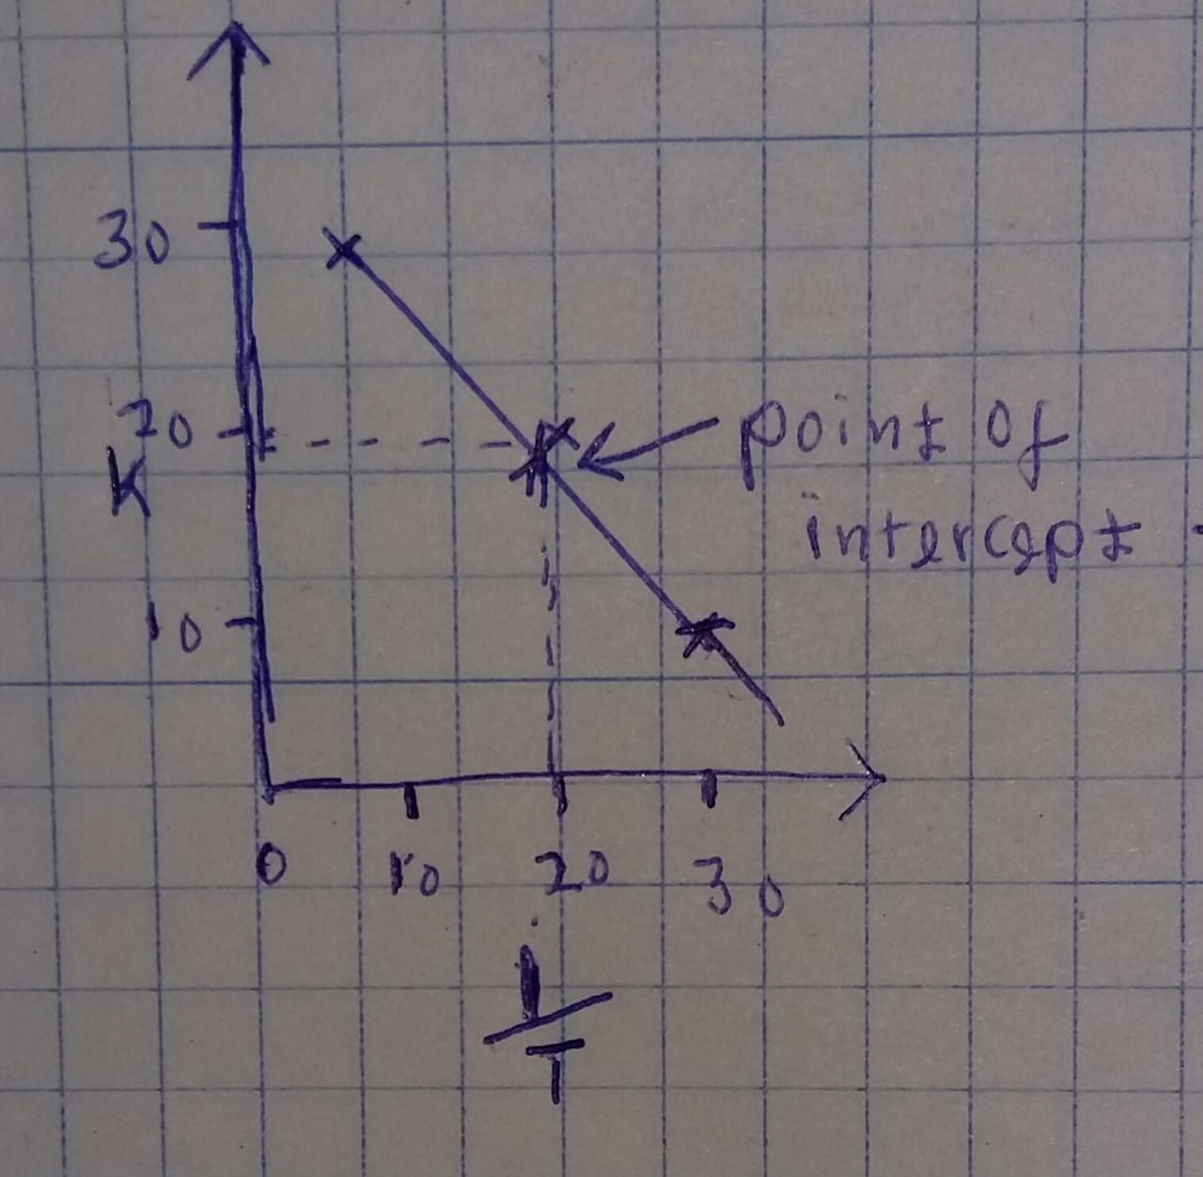

- Calculate ∆H° and ∆S° for the equilibrium under investigation. Note: remember to include units when reporting the values below.
H and S were determined indirectly using
Grm = Hrm - Srm
At the standard conditions Grm =586.486 k/cal/mol
When S is constant under same conditions.
H= 586.486 -120 =466.486 kcal/mol
S = 586.486 -466.486
=120+586.486
=706.486 kcal/mol

Slope = _____________________ y-Intercept = ______________________
∆H° = _____________________ ∆S° = ______________________

Student: (name)___________________________ (signature)_______________________________________________
Instructor: (signature)____________________ Bench # ______ Laboratory Section: ______
Effect of Temperature on Rate of Reaction Sign-out Checklist
Equipment Cleaned and Returned to Common Glassware Drawer | Initials
50 mL Beakers
Equipment Cleaned and Returned to CHEM 101 Special Issue Glassware | Initials
50 mL Volumetric Flask, 5 mL and 20 mL Pipets
Equipment Cleaned and Returned to Side/Back Bench | Initials
Test Tubes
Equipment Remaining on Students Bench | Initials
Lab Quest with power cord
Spectrophotometer with USB Cable
Temperature probe
Other Cleaning and/or Upkeep | Initials
Bench wiped with a damp paper towel
Sinks clear of broken/dirty glassware
Water bottles returned to end of bench

Report: Experiment Q (Chemical Equilibrium) & Experiment R (Reaction Thermodynamics)
Assessment
Experiments Q & R
Report (Paper) ______ /10
Quiz (Online) ______ /10
Deductions ______
Total ______ /20

Name: ____________________________ Bench #_______
Section: ___________ Date: _________________________
Laboratory Instructor: ___________________________

Note: The assessment for the Experiments Q & R consists of the online quiz based on Experiment R (see the CHEM 102 Laboratory BlackBoard Site), the calculations on the Observation Sheets for Experiments Q and R (Q-11 to Q-14, R-11, and R-12) and the Laboratory Report for Experiment Q (Pages R-15 through R-17).

Part I: Effect of concentration and temperature on the iron(III) thiocyanate equilibrium
- When Fe(NO₃)₃(aq) and KSCN(aq) were initially mixed they reacted and established an equilibrium with [Fe(SCN)]²⁺(aq). Write the net ionic chemical equation for this reaction. Calculate Q for the moment at which the solutions are mixed (t = 0 s). Indicate how the reagent concentrations will change as the reaction proceeds. (0.5)
Fe (NO₃)₃(aq) + KSCN(aq) ------> [FeSCN](NO₃)₂ + K(NO₃)
At t = 0,
Q value = [[FeSCN](NO₃)₂]*[K(NO₃)] / [Fe(NO₃)₃] * [KSCN]
so, Q = 0. as no products are present.
The concentration of the reactants will decrease exponentially and increases that of product exponentially.

For questions 2 and 3, use Le Châtelier's Principle and the “fill in the blank” format provided to explain the effect the added reagent has on the [Fe(SCN)]²⁺(aq) equilibrium. If an secondary equilibrium is present, support your answer by providing the appropriate balanced net ionic secondary equilibria. The Advance Study assignment may be of assistance.

- How does the addition of KSCN(aq) affect the equilibrium position for reaction (1)? (0.5)
Addition of KSCwN(aq) shift the equilibrium in forward direction to gain the increased concentration of SCN to left side.

The added ____KSCN______ will react with the ____Fe³⁺______ already present in solution to form __[Fe(SCN)]²⁺________. This happens because the system is not at equilibrium immediately following the addition of _____KSCN_____. The value of Q is momentarily _____less__ than the value of K_{eq}. This is confirmed by the following observation: ______
The precipitate dissolved until Q become greater than K_{eq}
- How does the addition of NaOH(aq) affect the equilibrium position for reaction (1)? (0.6)
Adding NaOH-Fe³⁺ will lead to dissolution leading to formation of Fe (OH)₃ therefore the equilibrium will move in the backward direction to compensate the loss of Fe³⁺
The ____NaOH______ added will react with the free ___ Fe³⁺_______ in solution forming ___ Fe (OH)₃___, momentarily causing the concentration of _____ Fe³⁺_____ to ___decrease. The primary equilibrium will shift ___backward direction, restoring K_{eq} by replacing the ___Q_(reaction quotient). This shift will result in a(n) _decrease in the concentration of ___[Fe(SCN)²⁺causing the color intensity of the solution to _____decrease.

- Use your qualitative experimental observations (from Experiment Q) to explain how equilibrium (1) systematically changes with temperature. (0.4)

Chemical reaction of Fe³⁺_{(aq)} +SCN⁻>>Fe(SCN)²⁺is a dynamic reaction in which the forward reaction exothermic reaction.
Fe³⁺ions changes to Fe²⁺ by exothermic reaction at room temperature thus becoming brown color liquid.
Fe³⁺_{(aq)} +SCN⁻_{(aq)}>>Fe(SCN)²⁺
Fe(SCN)²⁺ is a clear brown liquid
The secondary equilibrium product is the Silver precipitate.
All Fe²⁺ ions are used in the exothermic reactions that leads to reverse reaction to form Fe³⁺ ions from surrounding making the change of enthalpy to be positive.

- Rewrite equilibrium (1) with heat expressed as either a reactant or as a product, so that Le Châtelier's Principle will predict the observed effects of temperature changes on the reaction equilibrium. Base your discussion on the qualitative observations made during Experiment Q. (0.2)
Le Châtelier's Principle state that if chemical reaction is in dynamic equilibrium it is affected by temperature, concentration, volume and pressure.
Here the forward reaction is favoured in cold water that produce more Fe²⁺.
After the addition of 5 drops of 2.5 M NaoH and equally 2 drops of 0.2M sodium oxalate concentration of Fe²⁺ reduces while drops of M Ag(No₃)_{(aq)} produces Ag⁺ ions precipitate.
Temperature increase favours Fe³⁺ ions.

- Is the equilibrium as written in Q5 exothermic or endothermic, based on the qualitative results from Experiment Q? Is this result consistent with the sign (+ or -) of ∆H° calculated on page R-11? (0.2)
For exothermic reaction and free energy for this reaction result to production of heat to the surrounding. From experiment Q the reaction was exothermic thus equilibrium shifts to the left side.

- Evaluate and discuss the overall success of your determination of the equilibrium constant, K, for reaction (1). In particular, consider the extent to which the measured value of K varies across the four solutions that you and your partner investigated. Suggest any sources of error (avoidable or otherwise) that affect the overall quality of your determination of K. (0.6)
The size of equilibrium constant show the extent to which reactions proceeds. If the equilibrium constant is large it means that the concentration of the product is also large. If the equilibrium is small it indicate that the concentration of reactant is large.
In the experiment the value of K increase as the concentration of the products increase in the four solution.

End of Report

